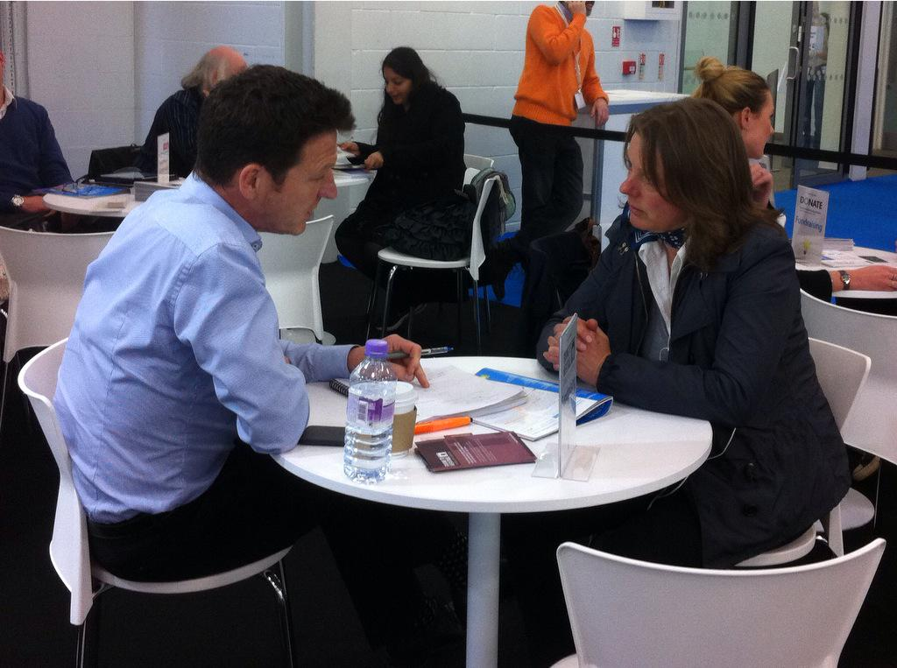
Giving to Heritage is a training partnership between the Institute of Fundraising and the Heritage Alliance. This Heritage Lottery Funded project ends in March 2016.

What do we offer?
We offer one day training workshops all over the country on 12 different fundraising topics. Each workshop is just £20 per person per day.
Our one-to-one support and consultancy sessions give you the opportunity to receive advice from a fundraising expert for free on any fundraising related issues.
We have also recently started a series of free webinars covering a variety of fundraising topics.

Getting to know your Donors- Profiling your Audience and Improving your Marketing
This one day workshop is packed with practical tools and tips to help heritage projects analyse their visitors and so shape marketing messages and communications and engage audiences with heritage. | 20 November, Kelmscott House
Major Donor Fundraising
Pick up the tools to start a major donor programme in your heritage organisation, and learn about an eight-step process in identifying and securing major individual donors. | 04 November, Durham Cathedral
 | 25 November, London
Measuring and Communicating Impact
Develop ways to communicate and discover appropriate methods and tools to measure the heritage impact for each delegate. | 10 December, Manchester
Social Media and Digital Fundraising for Heritage Organisations
Discover media tools to generate income and supporters and gain practical ideas to assist your organisation. | 01 December, SeaCity, Southampton
Corporate Partnerships
Identify, interrogate, pitch and steward appropriate corporate partnerships to generate income for heritage assets. | 19 January, Ironbridge, Shropshire
 | 11 February, Leeds
Securing Support for your Heritage Project through Grant-Making Trusts and Foundations
Understand how to identify a need, research donors, write a compelling application and maintain ongoing donor relationships. | 17 November, Peterborough
 | 03 December, Bristol
 | 09 December, London
 | 15 January, Leicester
Legacy Marketing for Heritage Organisations
Cover all aspects of legacy fundraising, and how it can be used to generate long term income using methods that require minimum investment. | 04 November, Manchester
 | 10 November, St Albans
 | 28 January, Doncaster
Fundraising Roles & Responsibilities of Trustees on Heritage Boards
Designed specifically for trustees – this workshop focuses on the part that Trustees can play in the fundraising process. | 22 January, London
 | 02 February, Manchester
Raising Funds from the Community for your Heritage Project
Community fundraising is a rapidly growing income stream for heritage organisations. This one day workshop packed with hints and tips to engage with your visitors and supporters; encouraging them to fundraise in aid of your heritage project as groups and individuals. | 23 November, Coventry Transport Museum

